Bootstrap is a popular style sheet. To include Bootstrap include:

<link rel="stylesheet" href="http://maxcdn.bootstrapcdn.com/bootstrap/3.2.0/css/bootstrap.min.css">

**To study Bootstrap** <http://www.w3schools.com/bootstrap/default.asp>

Then in the html you may use the classes:

<div class="container">  
  
<table class="**table table-striped**">

<button class="btn btn-success"

To have this image button in each row of a grid or outsie



Use

      <button class="btn"   
      <span class="glyphicon glyphicon-pencil"></span>&nbsp;&nbsp;Edit  
      </button>

For this button



Use these classes

<button class="btn btn-success">  
  <span class="glyphicon glyphicon-user"></span> Create New User  
</button>

<!DOCTYPE html>  
<html>

<link rel="stylesheet" href="http://maxcdn.bootstrapcdn.com/bootstrap/3.2.0/css/bootstrap.min.css">  
<script src="http://ajax.googleapis.com/ajax/libs/angularjs/1.3.14/angular.min.js"></script>

<body ng-app="myApp" ng-controller="userCtrl">

<div class="container">  
  
<h3>Users</h3>  
  
<table class="**table table-striped**">

  <thead><tr>  
    <th>Edit</th>  
    <th>First Name</th>  
    <th>Last Name</th>  
  </tr></thead>

  <tbody>

<tr ng-repeat="user in users">  
    <td>  
      <button class="btn" ng-click="editUser(user.id)">  
      <span class="glyphicon glyphicon-pencil"></span>&nbsp;&nbsp;Edit  
      </button>  
    </td>  
    <td>{{ user.fName }}</td>  
    <td>{{ user.lName }}</td>  
  </tr></tbody>

</table>  
  
<hr>  
<button class="btn btn-success" ng-click="editUser('new')">  
  <span class="glyphicon glyphicon-user"></span> Create New User  
</button>  
<hr>  
  
<h3 ng-show="edit">Create New User:</h3>  
<h3 ng-hide="edit">Edit User:</h3>  
  
<form class="form-horizontal">  
<div class="form-group">  
  <label class="col-sm-2 control-label">First Name:</label>  
  <div class="col-sm-10">  
    <input type="text" ng-model="fName" ng-disabled="!edit" placeholder="First Name">  
  </div>  
</div>   
<div class="form-group">  
  <label class="col-sm-2 control-label">Last Name:</label>  
  <div class="col-sm-10">  
    <input type="text" ng-model="lName" ng-disabled="!edit" placeholder="Last Name">  
  </div>  
</div>  
<div class="form-group">  
  <label class="col-sm-2 control-label">Password:</label>  
  <div class="col-sm-10">  
    <input type="password" ng-model="passw1" placeholder="Password">  
  </div>  
</div>  
<div class="form-group">  
  <label class="col-sm-2 control-label">Repeat:</label>  
  <div class="col-sm-10">  
    <input type="password" ng-model="passw2" placeholder="Repeat Password">  
  </div>  
</div>  
</form>  
  
<hr>

<button class="btn btn-success" ng-disabled="error || incomplete">  
  <span class="glyphicon glyphicon-save"></span> Save Changes  
</button>

</div>  
  
<script src = "myUsers.js"></script>  
</body>  
</html>

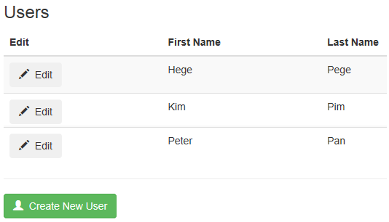

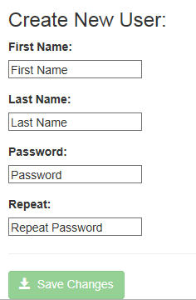

Directives (Used Above) Explained

|  |  |
| --- | --- |
| **AngularJS Directive** | **Description** |
| <body ng-app | Defines an application for the <body> element |
| <body ng-controller | Defines a controller for the <body> element |
| <tr ng-repeat | Repeats the <tr> element for each user in users |
| <button ng-click | Invoke the function editUser() when the <button> element is clicked |
| <h3 ng-show | Show the <h3>s element if edit = true |
| <h3 ng-hide | Hide the <h3> element if edit = true |
| <input ng-model | Bind the <input> element to the application |
| <button ng-disabled | Disables the <button> element if error or incomplete = true |

Bootstrap Classes Explained

|  |  |  |
| --- | --- | --- |
| **Element** | **Bootstrap Class** | **Defines** |
| <div> | container | A content container |
| <table> | table | A table |
| <table> | table-striped | A striped table |
| <button> | btn | A button |
| <button> | btn-success | A success button |
| <span> | glyphicon | A glyph icon |
| <span> | glyphicon-pencil | A pencil icon |
| <span> | glyphicon-user | A user icon |
| <span> | glyphicon-save | A save icon |
| <form> | form-horizontal | A horizontal form |
| <div> | form-group | A form group |
| <label> | control-label | A control label |
| <label> | col-sm-2 | A 2 columns span |
| <div> | col-sm-10 | A 10 columns span |